Darian Byrne, Milosz Cwynar, Kyle Purcell

**C00296036, C00301808, C00299782**

Abstract

For our software project, we are designing a hotel booking system that users can use to book a stay and events at a four-star hotel. The system will consist of a user interface, where users can book from the following options:

Hotel Booking System

Systems Analysis and Testing 24/25

Table of Contents

Summary 3

User Stories 4

Booking & Payment 4

Browse Rooms 4

Book Room 4

Reserve Table 4

Book Gym 4

Purchase Pass 4

Book Spa 5

Book Spa 5

Book Wedding 5

Book Conference 5

View Availability 5

View Menu 5

View Menu 5

Use Case Diagram 6

Scenario Specifications 7

Use case name: Booking & Payment 7

Use case name: Browse Rooms 8

Use case name: Book Room 9

Use case name: Reserve Table 9

Use case name: Book Gym 10

Use case name: Purchase Pass 10

Use case name: Book Spa 11

Use case name: Book Wedding 11

Use case name: Book Conference 12

Use case name: View Availability 12

Use case name: View Menu 13

Class Diagram 14

Sequence Diagrams 15

Booking & Payment 15

Browse Rooms 16

Book Room 17

Reserve Table 18

Book Gym 19

Purchase Pass 20

Book Spa 21

Book Wedding 22

Book Conference 23

View Availability 24

View Menu 25

Message Analysis Tables 26

Booking & Payment 26

Browse Rooms 27

Book Room 27

Reserve Table 28

Book Gym 28

Purchase Pass 29

Book Spa 29

Book Wedding 30

Book Conference 30

View Availability 31

View Menu 31

Test Cases 32

Booking & Payment 32

Browse Rooms 32

Book Room 32

Reserve Table 33

Book Gym 33

Purchase Pass 33

Book Spa 33

Book Wedding 34

Book Conference 34

View Availability 34

View Menu 34

Contributions 35

Hotel Booking

# Summary

For our software project, we are designing a hotel booking system that users can use to book a stay and events at a four-star hotel. The system will consist of a user interface, where users can book from the following options:

* Room
* Conference
* Wedding
* Restaurant reservation
* Spa session
* Gym session

In addition, users can select a type of room and view availability. Users can also view availability for booking weddings, conferences, spa sessions, gym sessions, and making restaurant reservations. When making a restaurant reservation, users have the additional option of viewing the restaurant menu.

Once users select their booking and dates, they can proceed to making a payment, upon where they will receive confirmation of their booking.

Users who wish to only book a conference, spa session, gym session, or make a restaurant reservation can do so without having to book a stay at the hotel. There are day passes available at the gym for non-guests.

The system will also consist of a database for storing each of the following information about the hotel:

* Number of rooms available
* Number of bookings
* Guest payments

# User Stories

|  |  |
| --- | --- |
| Story Identifier: | STK010 |
| Story Name: | Booking & Payment |
| Description: | As a hotel guest, I want to make a payment, so that I can confirm my booking. |
| Confirmation: | With what payment methods can I make a payment?  Is the payment method I use secure?  How will I receive confirmation of my booking? |

|  |  |
| --- | --- |
| Story Identifier: | STK020 |
| Story Name: | Browse Rooms |
| Description: | As a hotel guest, I want to browse rooms, so that I know which type of room I would like to book. |
| Confirmation: | How will I view the rooms available?  What type of rooms can I view? |

|  |  |
| --- | --- |
| Story Identifier: | STK030 |
| Story Name: | Book Room |
| Description: | As a hotel guest, I want to be able to book a room online, so that I can stay at the hotel. |
| Confirmation: | How will I be able to book a room?  Can I choose the number of people booking the room? ￼ |

|  |  |
| --- | --- |
| Story Identifier: | STK040 |
| Story Name: | Reserve Table |
| Description: | As a hotel guest/customer, I want to reserve a table, so that I can eat at the restaurant. |
| Confirmation: | How can I reserve a table at the restaurant?  Will I receive confirmation of my reservation?  Can I amend or cancel my reservation? |

|  |  |
| --- | --- |
| Story Identifier: | STK050 |
| Story Name: | Book Gym |
| Description: | As a hotel guest, I want to book a PT session, so that I can learn how to use the gym. |
| Confirmation: | How can I book a PT session at the gym?  Can I choose a preference of Personal Trainers available? |

|  |  |
| --- | --- |
| Story Identifier: | STK060 |
| Story Name: | Purchase Pass |
| Description: | As a customer, I want to purchase a pass, so that I can go to the gym. |
| Confirmation: | How can I make a payment for the day pass? |

|  |  |
| --- | --- |
| Story Identifier: | STK070 |
| Story Name: | Book Spa |
| Description: | As a hotel guest, I want to book a spa treatment, so that I can get a massage. |
| Confirmation: | Does the hotel guest get a discount?  Does the hotel guest get to choose the gender of the masseuse? |

|  |  |
| --- | --- |
| Story Identifier: | STK071 |
| Story Name: | Book Spa |
| Description: | As a customer, I want to book a spa, so that I can relax. |
| Confirmation: | Does the customer get to choose the gender of the masseuse? |

|  |  |
| --- | --- |
| Story Identifier: | STK080 |
| Story Name: | Book Wedding |
| Description: | As a hotel guest or a customer, I want to book a wedding, so that I host a marriage ceremony for my family member/friend. |
| Confirmation: | Does the customer need to specify how many guests they are bringing?  How far in advance must the booking be placed? |

|  |  |
| --- | --- |
| Story Identifier: | STK090 |
| Story Name: | Book Conference |
| Description: | As a customer, I want to book a conference room, so that I can host a meeting or an event. |
| Confirmation: | Does the customer need to specify how many guests they are bringing? Does the customer need to specify catering? Does the customer need to specify the type of the event? |

|  |  |
| --- | --- |
| Story Identifier: | STK100 |
| Story Name: | View Availability |
| Description: | As a hotel guest, I want to view availability, so that I know what days suit me to book. |
| Confirmation: | Does the system show exactly how many places are available? Does the system show accurate dates and times? |

|  |  |
| --- | --- |
| Story Identifier: | STK110 |
| Story Name: | View Menu |
| Description: | As a hotel guest, I want to see a menu, so that I can decide if I want to dine at the restaurant. |
| Confirmation: | Is the menu in the customers language? Does the menu have prices? |

|  |  |
| --- | --- |
| Story Identifier: | STK111 |
| Story Name: | View Menu |
| Description: | As a hotel guest, I want to see a menu, so that I can meet my dietary requirements and/or allergies. |
| Confirmation: | Does the menu show dietary requirements?  Does the menu show allergies contained within each item? |

# Use Case Diagram

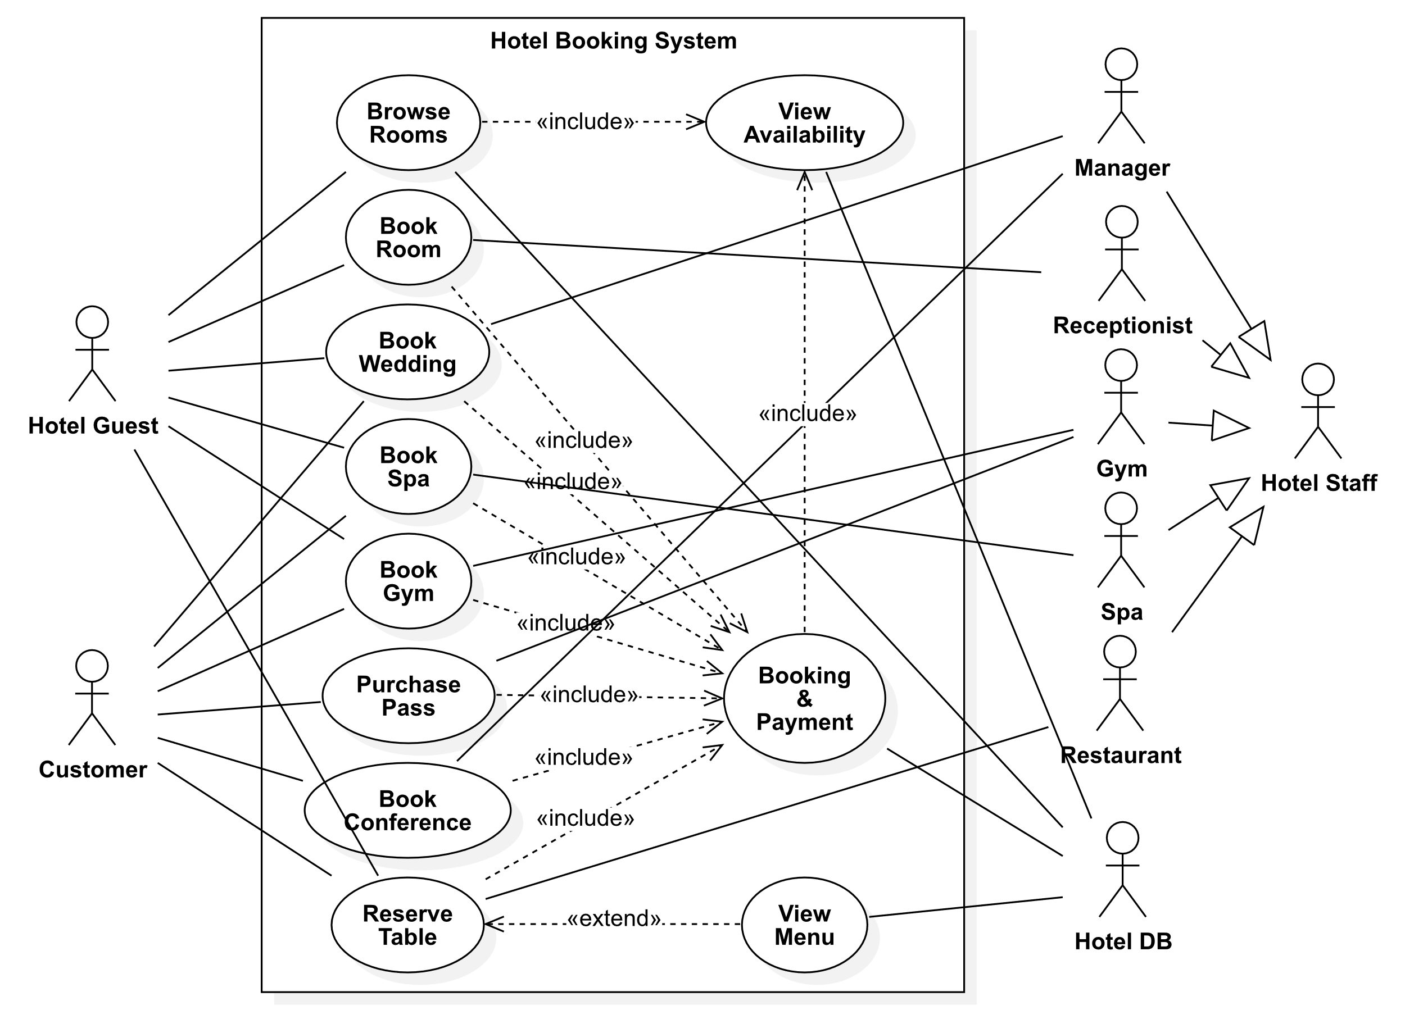

# Scenario Specifications

|  |  |
| --- | --- |
| Use case name: Booking & Payment | **UniqueID:** UC001 |
| **Area:** Accommodation, Gym, Spa, Restaurant, Wedding, Conference | |
| **Actor(s):** Hotel Guest, Customer, Hotel Database | |
| **Description:** Booking a type of experience at the hotel followed by making a payment for the selected booking. | |
| **Triggering Event:** Selecting an option to book and selecting book. | |
| **Trigger type:** **External** **Temporal** | |
| **Steps Performed (Main Path)** | **Information for Steps** |
| 1. Click book | Booking |
| 2. Select available date(s) | Date and Time |
| 3. Enter personal details | Customer |
| 4. Proceed to payment | Payment |
| 5. Choose payment method | Card Payment |
| 6. Enter payment details | Card Payment |
| 7. Click pay | Payment |
| 8. Receive confirmation of booking | Confirmation |
| 9. Receive a receipt for booking | Receipt |
| **Preconditions:**  Available dates for the type of booking being made  Having a valid payment method  Having an email address or phone number | |
| **Postconditions:**  Receiving confirmation of booking via email and/or phone  Receiving a receipt of payment via email | |
| **Assumptions:** Users can select the type of booking and would have a valid payment method along with an email address. | |
| **Requirements met:** The user can make and pay for a booking | |
| **Outstanding issues:** Users should be able to select the type of booking, make a payment, and receive confirmation of their booking via email along with a receipt of their payment. | |
| **Priority:** 1 | |
| **Risk:** High | |

|  |  |
| --- | --- |
| Use case name: Browse Rooms | **UniqueID:** UC002 |
| **Area:** Accommodation | |
| **Actor(s):** Hotel Guest, Hotel Database | |
| **Description:** Browsing the types of rooms available at the hotel and viewing their availability and prices | |
| **Triggering Event:** The user selecting accommodation and proceeding to view the rooms | |
| **Trigger type:** **External** **Temporal** | |
| **Steps Performed (Main Path)** | **Information for Steps** |
| 1. Select accommodation on the UI | Hotel |
| 2. View the types of rooms at the hotel | Room |
| 3. Select a type of room | Room |
| 4. View the price of the room | Room |
| 5. View the available dates for the type of room selected | Date and Time |
| **Preconditions:**  The user being able to access the UI  The user being able to select the accommodation tab on the UI | |
| **Postconditions:**  Seeing the types of rooms that are available and their prices  Seeing the dates available for the type of room selected | |
| **Assumptions:** The user can use the UI and browse rooms by selecting accommodation | |
| **Requirements met:** The user can browse the rooms | |
| **Outstanding issues:**  Users should be able to access the UI with ease and browse rooms by clicking on accommodation.  Users should be able to view the type of rooms and their corresponding prices  Users should be able to view the availability for the type of room selected | |
| **Priority:** 2 | |
| **Risk:** High | |

|  |  |
| --- | --- |
| Use case name: Book Room | **UniqueID:** UC003 |
| **Area:** Accommodation | |
| **Actor(s):** Hotel Guest, Hotel Database | |
| **Description:** Booking a type of room selected along with the selected date(s) | |
| **Triggering Event:** The user browsing rooms and selecting a type of room followed by the date(s) | |
| **Trigger type:** **External** **Temporal** | |
| **Steps Performed (Main Path)** | **Information for Steps** |
| 1. Select room | Room |
| 2. Enter number of guests | Booking |
| 3. Proceed to booking and payment | Booking |
| **Preconditions:** The user browsing the rooms available and selecting the dates for the room | |
| **Postconditions:** The user receives confirmation of the room booking along with a receipt of their payment | |
| **Assumptions:** The user has browsed the rooms available at the hotel and viewed the available dates | |
| **Requirements met:** The user can book a room | |
| **Outstanding issues:**  Users should be able to book the room that they selected on the correct dates that they selected for the booking  Users should be able to view a confirmation of their booking and receipt of payment | |
| **Priority:** 3 | |
| **Risk:** Medium | |

|  |  |
| --- | --- |
| Use case name: Reserve Table | **UniqueID:** UC004 |
| **Area:** Restaurant | |
| **Actor(s):** Hotel Guest, Customer, Restaurant Staff | |
| **Description:** Reserving a table in the restaurant at a particular date and time | |
| **Triggering Event:** The user selects to reserve a table | |
| **Trigger type:** **External** **Temporal** | |
| **Steps Performed (Main Path)** | **Information for Steps** |
| 1. Select reserve table option | RoomBooking |
| 2. Enter number of guests | RoomBooking |
| 3. Select manual table selection | RoomBooking |
| 4. Select an available table | Table, RoomBooking |
| 5. Proceed to booking | Booking |
| **Preconditions:** The user is a hotel guest or customer. | |
| **Postconditions:**  The HotelDB will contain the reservation.  The user receives a confirmation of their booking. | |
| **Assumptions:** The user is making a booking for 6 or less people | |
| **Requirements met:** The user can reserve a table at the restaurant. | |
| **Outstanding issues:** User should be able to have a table automatically selected for them. When a user chooses to manually select a table, an overhead view of the restaurant layout should be shown. The user should be charged a card authorisation. | |
| **Priority:** 4 | |
| **Risk:** Medium | |

|  |  |
| --- | --- |
| Use case name: Book Gym | **UniqueID:** UC005 |
| **Area:** Gym | |
| **Actor(s):** Hotel Guest, Customer, Gym Staff, Hotel Database | |
| **Description:** Booking a personal training session at the gym | |
| **Triggering Event:** The user selects book PT session on the UI of the hotel booking system | |
| **Trigger type:** **External** **Temporal** | |
| **Steps Performed (Main Path)** | **Information for Steps** |
| 1. Select gym on the UI | Gym |
| 2. View the types of gym sessions offered by the gym at the hotel | GymSession |
| 3. Select book gym session | GymSession, GymBooking |
| 4. Choose the duration of the session | Date, Time |
| 5. Proceed to booking and payment | Booking, Payment, Confirmation, Receipt |
| **Preconditions:**  Selecting Gym on the UI  Having a valid payment method | |
| **Postconditions:**  Receiving a booking confirmation via email  Receiving a receipt of payment via email | |
| **Assumptions:** The user selects gym on the UI to book a gym session | |
| **Requirements met:** The user can book a session at the gym. | |
| **Outstanding issues:** Users should be able to view the details of the personal training session and choose the duration of it | |
| **Priority:** 5 | |
| **Risk:** Medium | |

|  |  |
| --- | --- |
| Use case name: Purchase Pass | **UniqueID:** UC006 |
| **Area:** Gym | |
| **Actor(s):** Customer, Hotel database, hotel staff | |
| **Description:** Booking a pass for use of the gym followed by making a payment | |
| **Triggering Event:** Selecting the option to purchase the pass | |
| **Trigger type:** **External** **Temporal** | |
| **Steps Performed (Main Path)** | **Information for Steps** |
| 1. Selecting Purchase pass in the gym section | Booking |
| 2. Proceed to pay for the pass | Booking |
| **Preconditions:** The user is a customer of the hotel | |
| **Postconditions:** The HotelDB will contain the pass ID  The user will receive a confirmation for the pass | |
| **Assumptions:** The user wants to use the hotel gym | |
| **Requirements met:** The user can purchase a pass | |
| **Outstanding issues:** The user should be able to view the purchase confirmation on their receipt | |
| **Priority:** 6 | |
| **Risk:** High | |

|  |  |
| --- | --- |
| Use case name: Book Spa | **UniqueID:** UC007 |
| **Area:** Spa | |
| **Actor(s):** Hotel Guest, Customer, Spa | |
| **Description:** Booking the spa on a particular date | |
| **Triggering Event:** The user selects to book a spa treatment | |
| **Trigger type:** **External** **Temporal** | |
| **Steps Performed (Main Path)** | **Information for Steps** |
| 1. Select book spa option | SpaBooking |
| 2. Enter number of guests | SpaBooking |
| 3. Select treatment package | SpaBooking |
| 4. Proceed to booking | SpaBooking, Payment, Card Payment, Confirmation, Receipt |
| **Preconditions:** The user is a hotel guest or customer. | |
| **Postconditions:** The HotelDB will contain the reservation.  The user receives a confirmation of their booking. | |
| **Assumptions:** The user is making a booking for 1 or 2 people | |
| **Requirements met:** The user can make a booking at the spa. | |
| **Outstanding issues:** User should be presented with a discount if they book for 2 people. | |
| **Priority: 7** | |
| **Risk:** Medium | |

|  |  |
| --- | --- |
| Use case name: Book Wedding | **UniqueID:** UC008 |
| **Area:** Hotel | |
| **Actor(s):** Hotel Guest, Customer, Manager | |
| **Description:** Booking a wedding at the hotel on a particular date | |
| **Triggering Event:** The user selects to book a wedding | |
| **Trigger type:** **External** **Temporal** | |
| **Steps Performed (Main Path)** | **Information for Steps** |
| 1. Select book wedding option | WeddingBooking |
| 2. Enter number of guests | WeddingBooking |
| 3. Select civil or religious ceremony | WeddingBooking |
| 4. Enter groom and bride details | Hotel Guest/Customer, WeddingBooking |
| 5. Select indoor or outdoor ceremony | WeddingBooking |
| 6. Select after party or dinner | WeddingBooking |
| 7. Proceed to booking | WeddingBooking |
| **Preconditions:** The user is a hotel guest or customer. | |
| **Postconditions:** The HotelDB will contain the reservation.  The user receives a confirmation of their booking. | |
| **Assumptions:** The user is making a booking for 50 to 150 people. The user is not already married. | |
| **Requirements met:** The user can make a booking for their wedding. | |
| **Outstanding issues:** The user should be contacted by the manager to arrange any other special details. | |
| **Priority:** 5 | |
| **Risk:** Medium | |

|  |  |
| --- | --- |
| Use case name: Book Conference | **UniqueID:** UC009 |
| **Area:** Conference | |
| **Actor(s):** Customer, Manager, Hotel DB | |
| **Description:** Booking out a conference for meeting at the hotel then followed by making a payment for the booked conference | |
| **Triggering Event:** Selecting an option to book a conference | |
| **Trigger type:** **External** **Temporal** | |
| **Steps Performed (Main Path)** | **Information for Steps** |
| 1. Select conference room | ConferenceBooking |
| 2. Proceed to booking and payment | Payment, Card Payment, Confirmation |
| **Preconditions:** The user browsing the conference rooms available and selecting the date | |
| **Postconditions:** The user receives confirmation of the conference booking along with a receipt of the payment | |
| **Assumptions:** The user has browsed the conference room availability and viewed the available dates | |
| **Requirements met:** The user can book a conference | |
| **Outstanding issues:**  Users should be able to book the conference that they selected on the correct dates that they selected for the booking  Users should be able to view a confirmation of their booking and receipt of payment | |
| **Priority:** 9 | |
| **Risk:** Medium | |

|  |  |
| --- | --- |
| Use case name: View Availability | **UniqueID:** UC010 |
| **Area:** Accommodation, Gym, Conference, Spa, Restaurant | |
| **Actor(s):** Hotel Guest, Customer, Hotel Database | |
| **Description:** Viewing the availability of a potential service prior to booking | |
| **Triggering Event:** The user wanting to book a particular experience at the hotel and to see if the dates they want to book the experience on are available | |
| **Trigger type:** **External** **Temporal** | |
| **Steps Performed (Main Path)** | **Information for Steps** |
| 1. Choose the date(s) for the type of service selected on the calendar | Service, Date and Time |
| **Preconditions:** A type of service being selected on the interface. The user has selected the type of service prior to viewing the availability | |
| **Postconditions:** Available dates for the service are selected | |
| **Assumptions:** The user selects the type of servuce prior to viewing the availability | |
| **Requirements met:** The user can view the availability of a service | |
| **Outstanding issues:** Users should be able to click on date(s) on the calendar and see if they are available prior to proceeding to booking and payment | |
| **Priority:** 7 | |
| **Risk:** High | |

|  |  |
| --- | --- |
| Use case name: View Menu | **UniqueID:** UC011 |
| **Area:** Restaurant | |
| **Actor(s):** Hotel Guest, Customer, HotelDB | |
| **Description:** Viewing the contents of the menu | |
| **Triggering Event:** Selecting the option to view the menu | |
| **Trigger type:** **External** **Temporal** | |
| **Steps Performed (Main Path)** | **Information for Steps** |
| 1.Selecting to view the menu | Menu, HotelDB |
| 2.Selecting the category of the menu | HotelDB |
| **Preconditions:** The user is a hotel guest or customer. | |
| **Postconditions:** The HotelDB will contain the menu | |
| **Assumptions:** The menu has a list of menu items | |
| **Requirements met:** The user can view the menu. | |
| **Outstanding issues:** The menu is displayed. Are the dietary needs displayed? | |
| **Priority:** 11 | |
| **Risk:** High | |

# Class Diagram

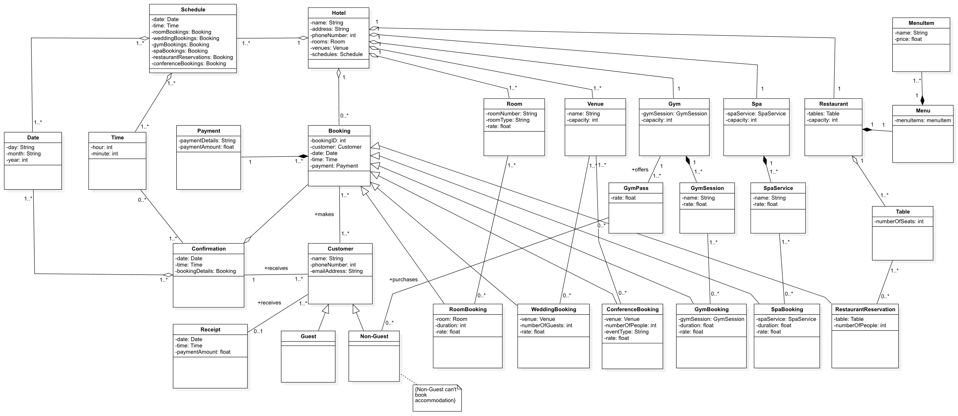

# Sequence Diagrams

## Booking & Payment

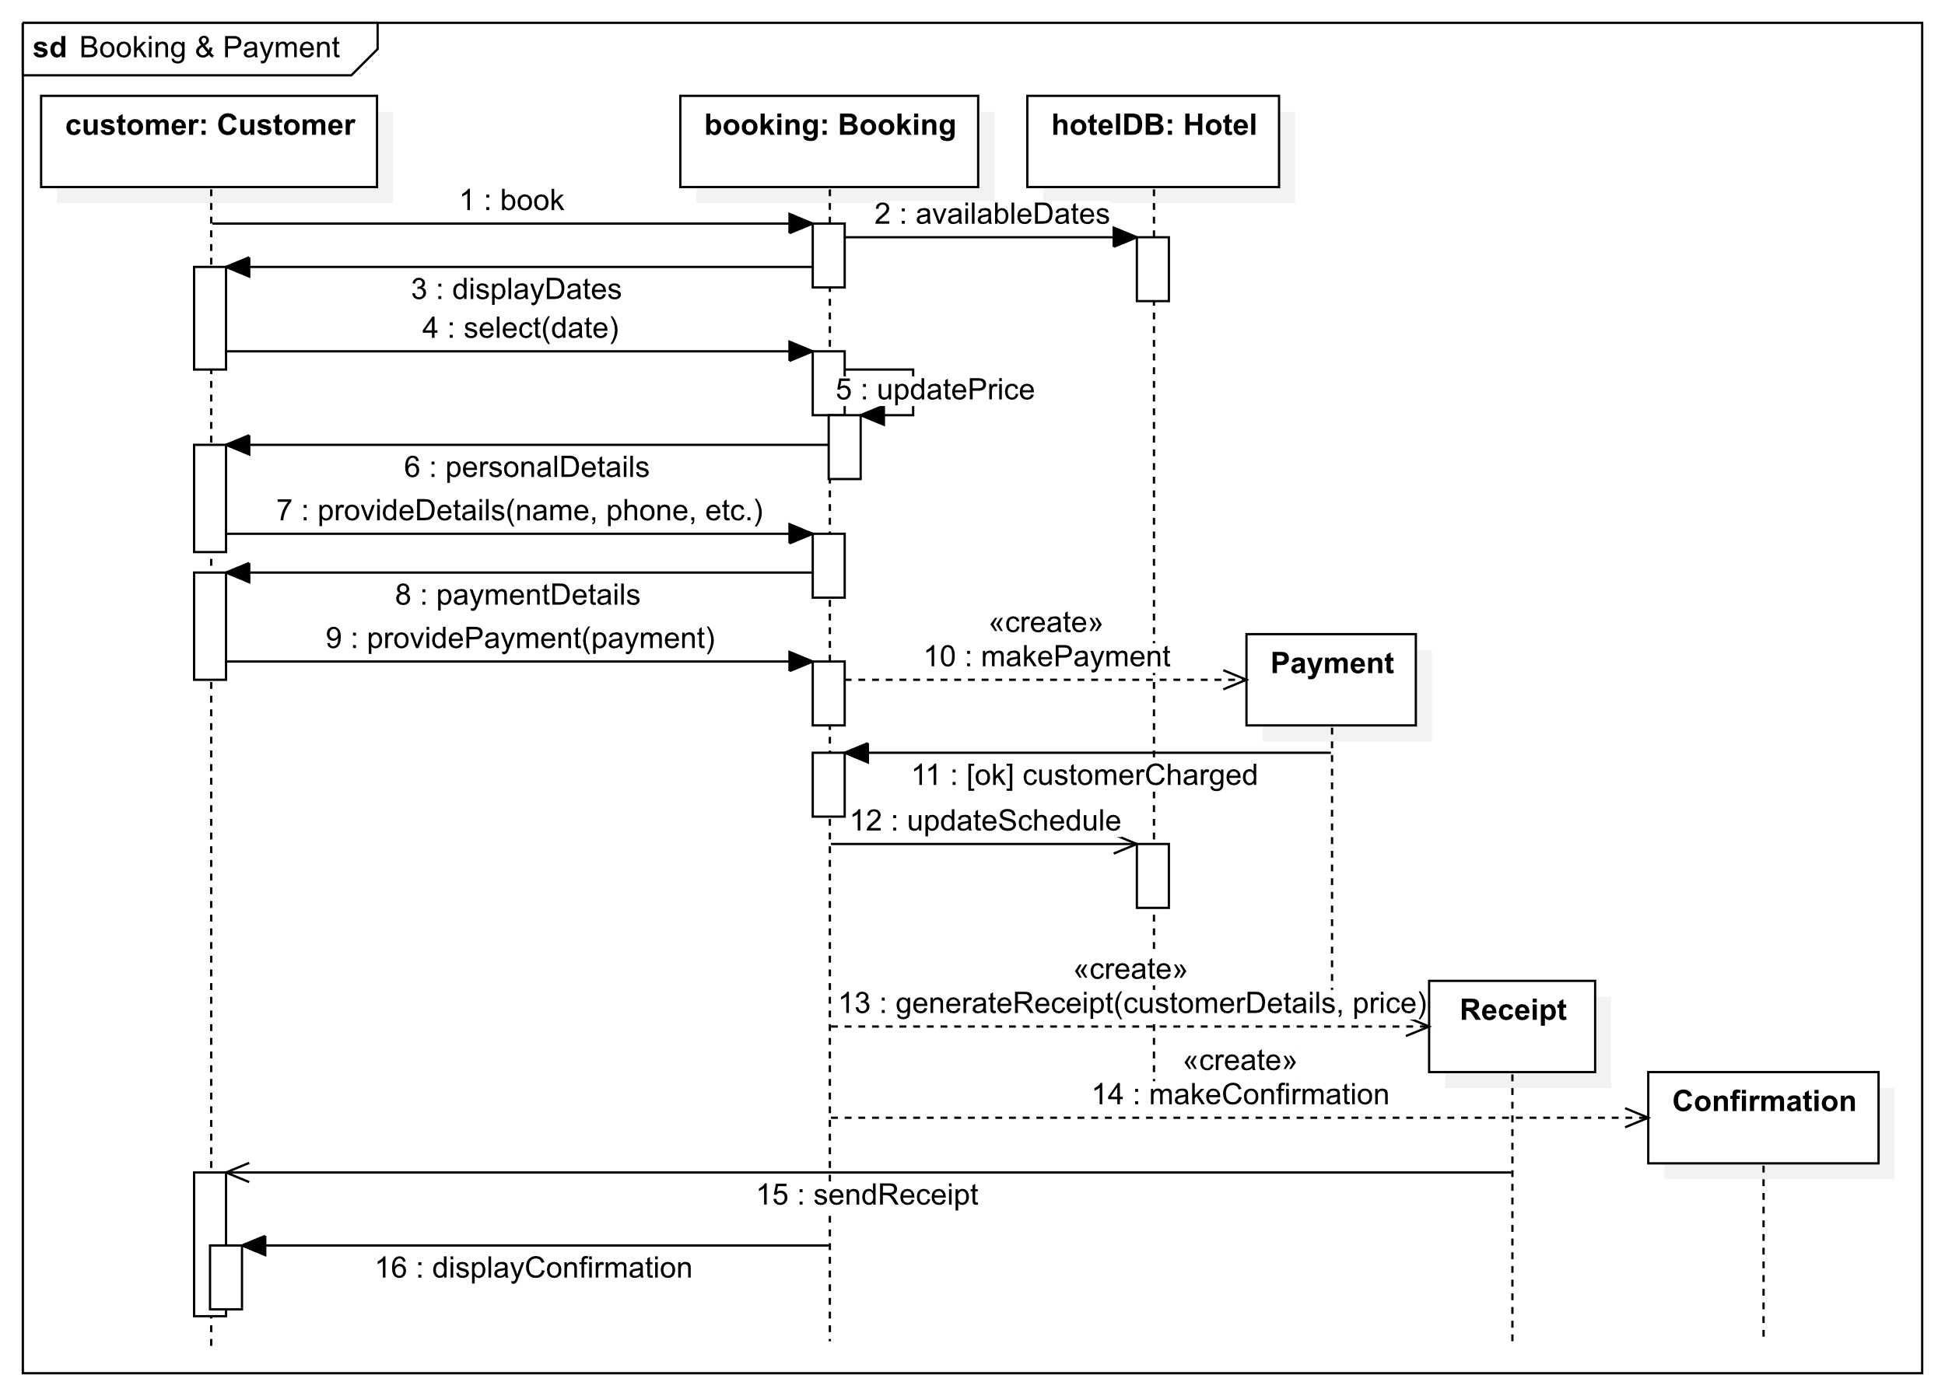

## Browse Rooms

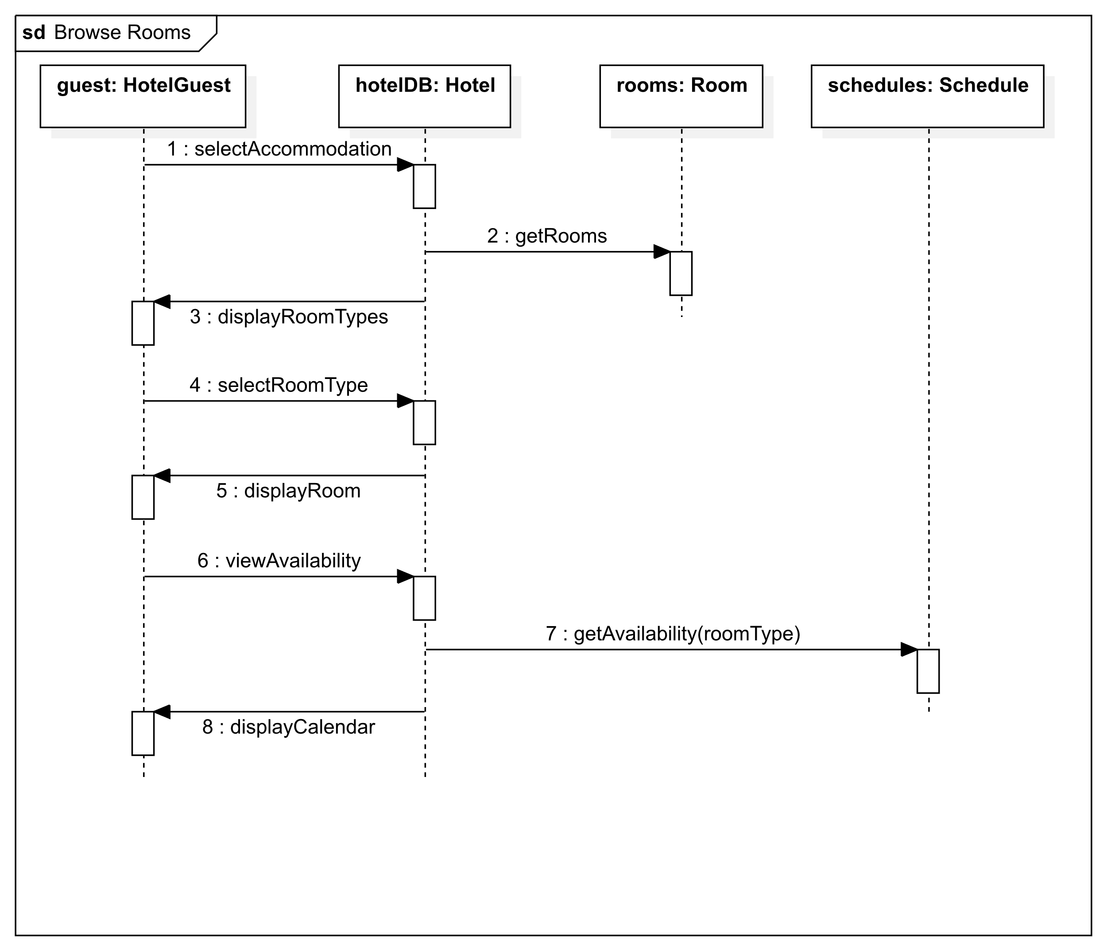

## Book Room

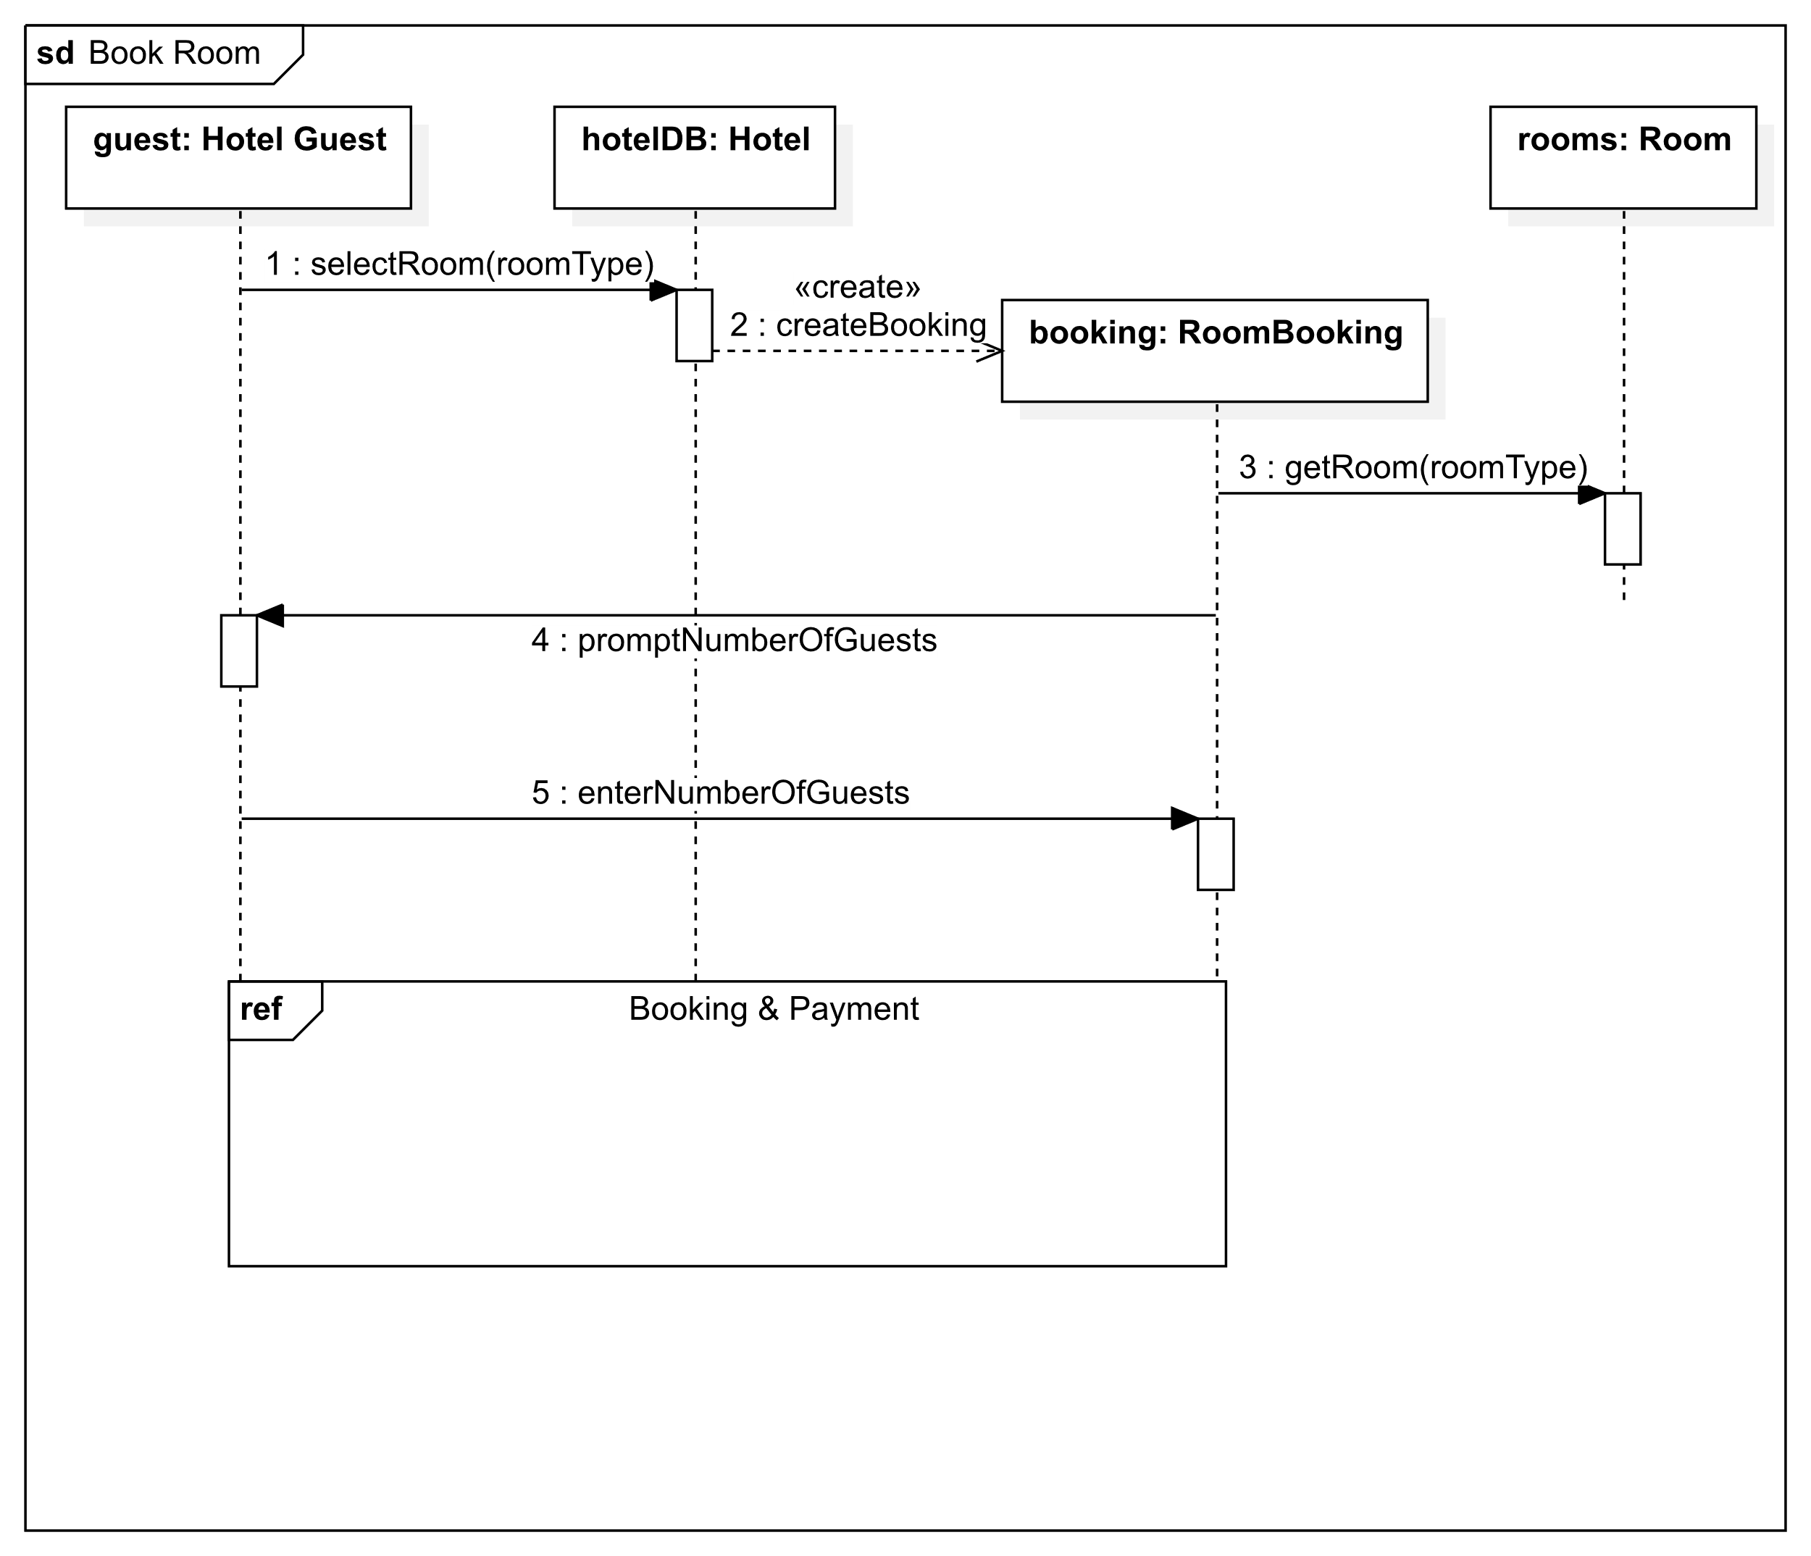

## Reserve Table

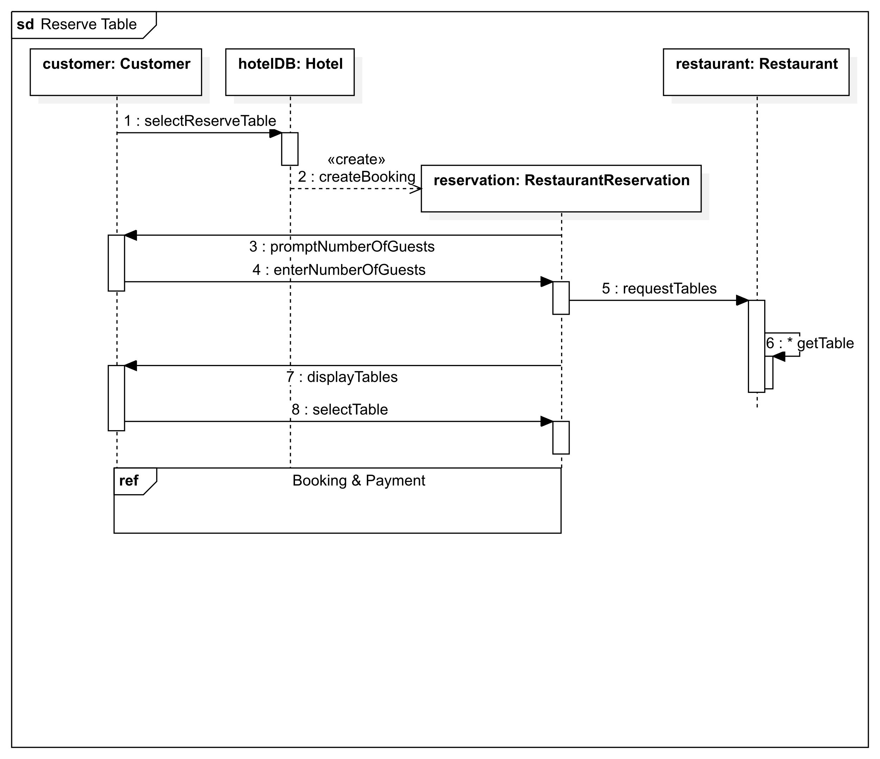

## Book Gym

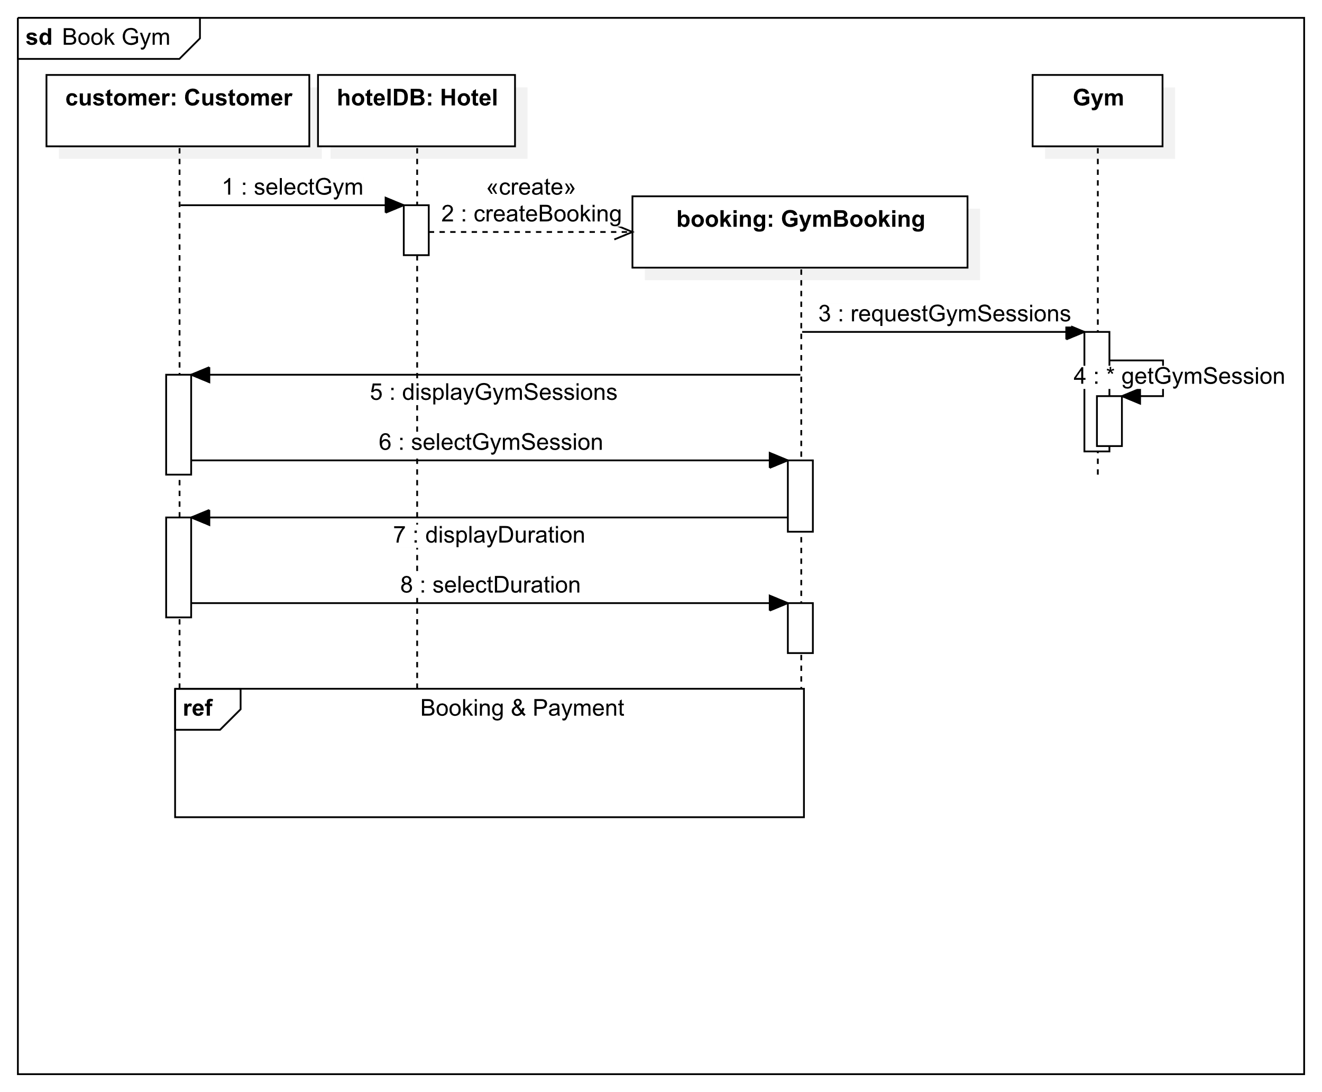

## Purchase Pass

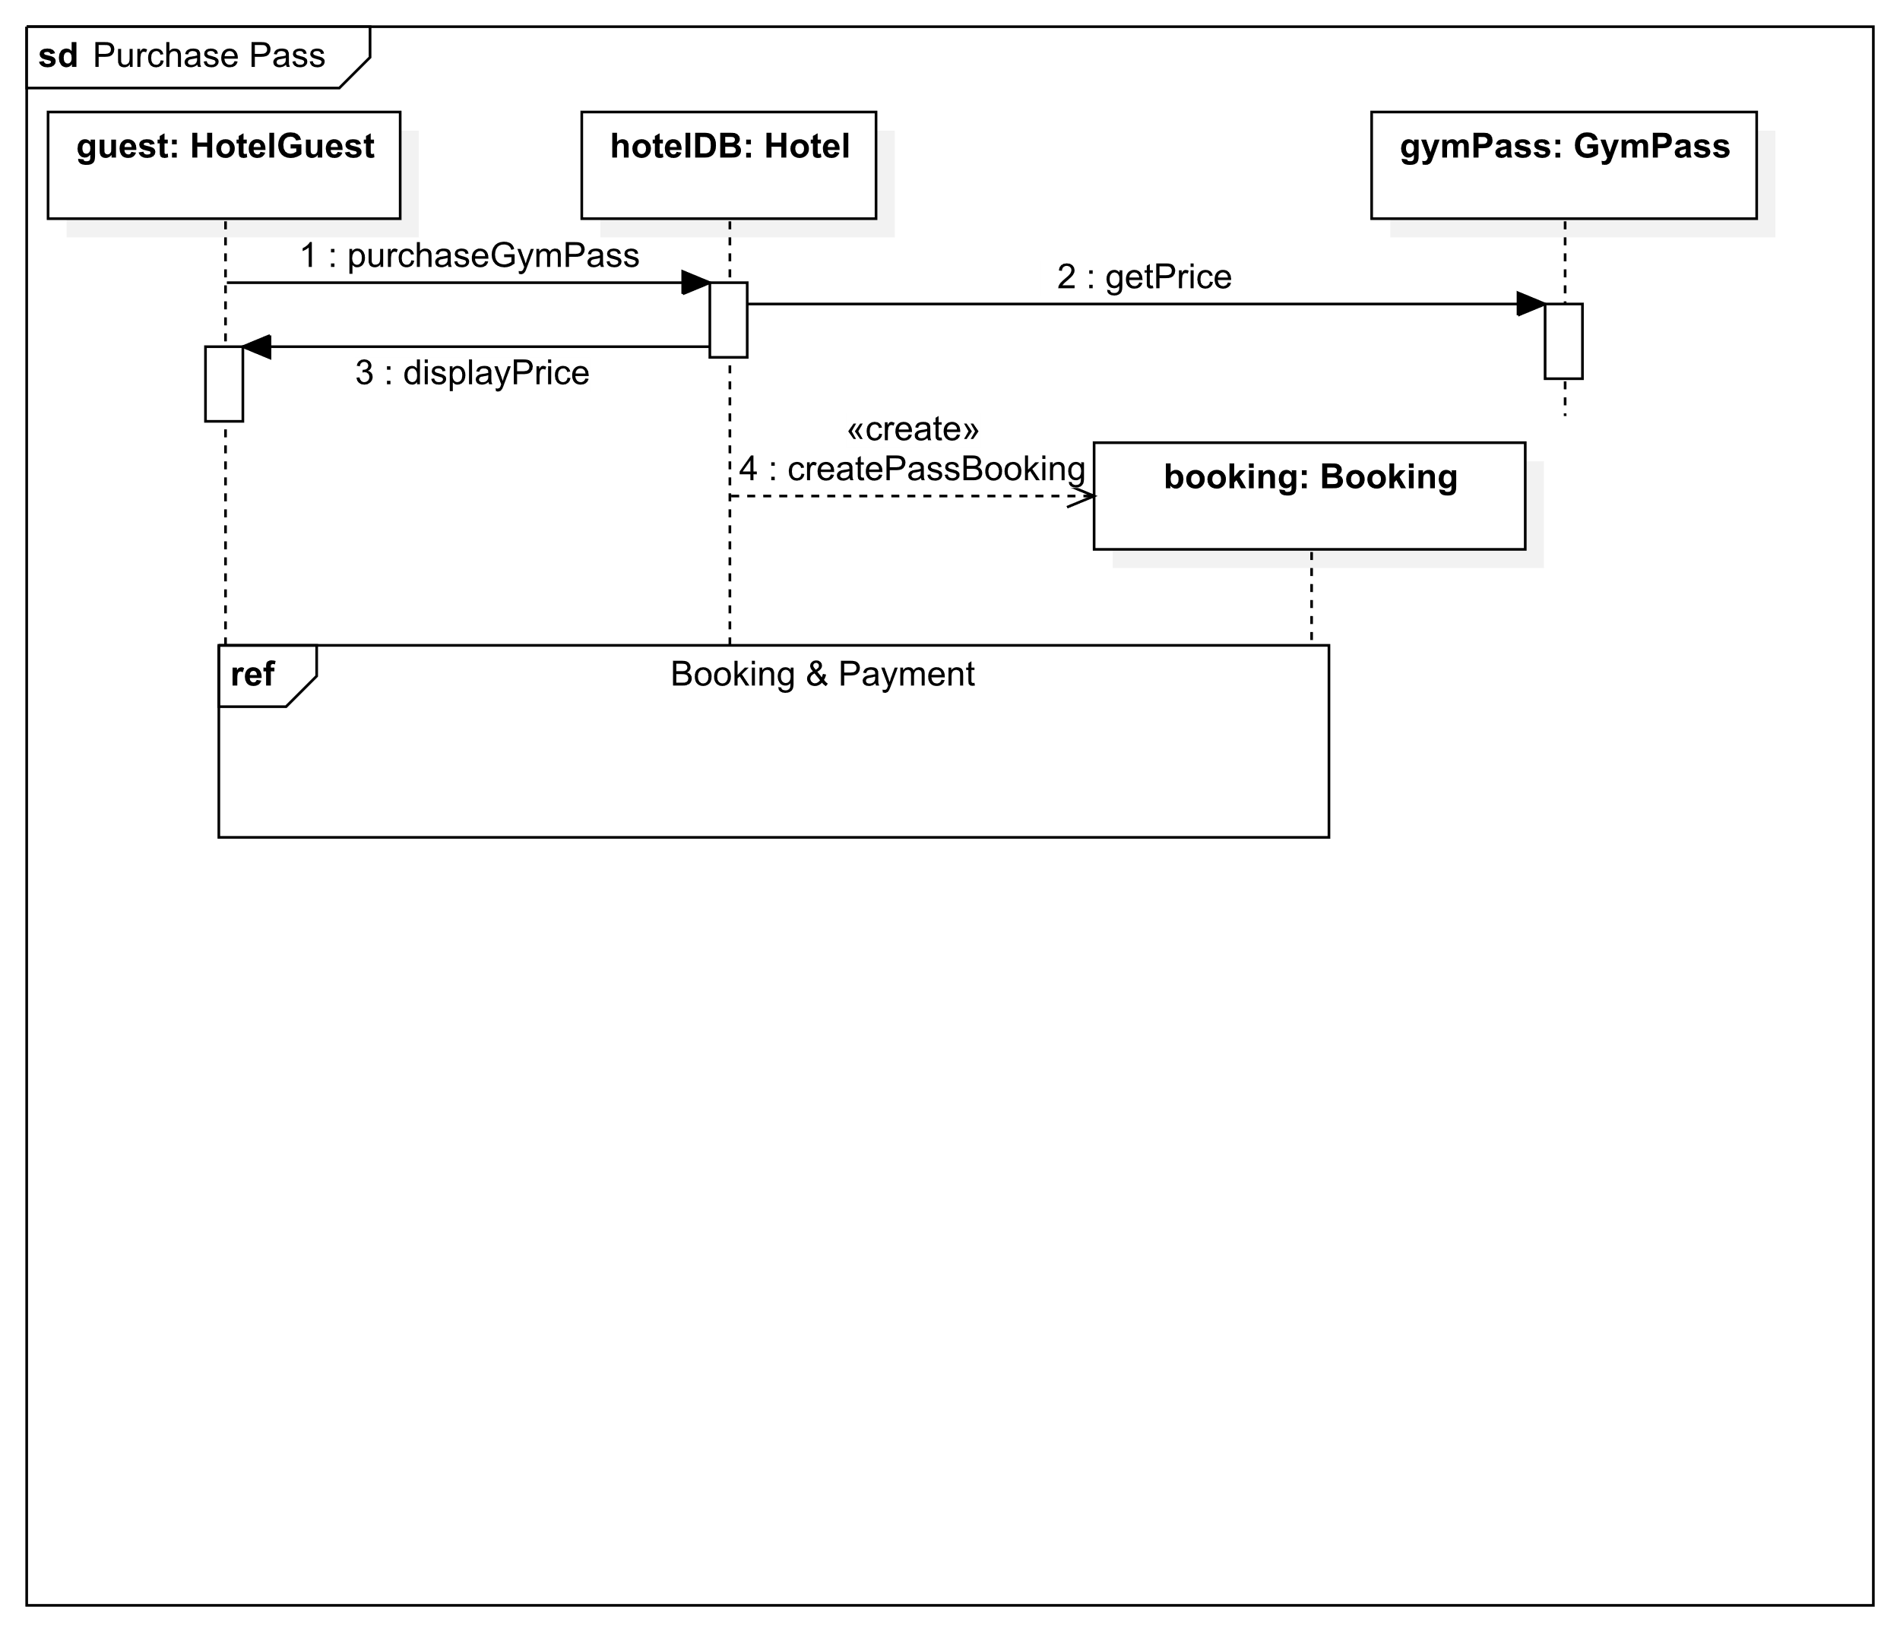

## Book Spa

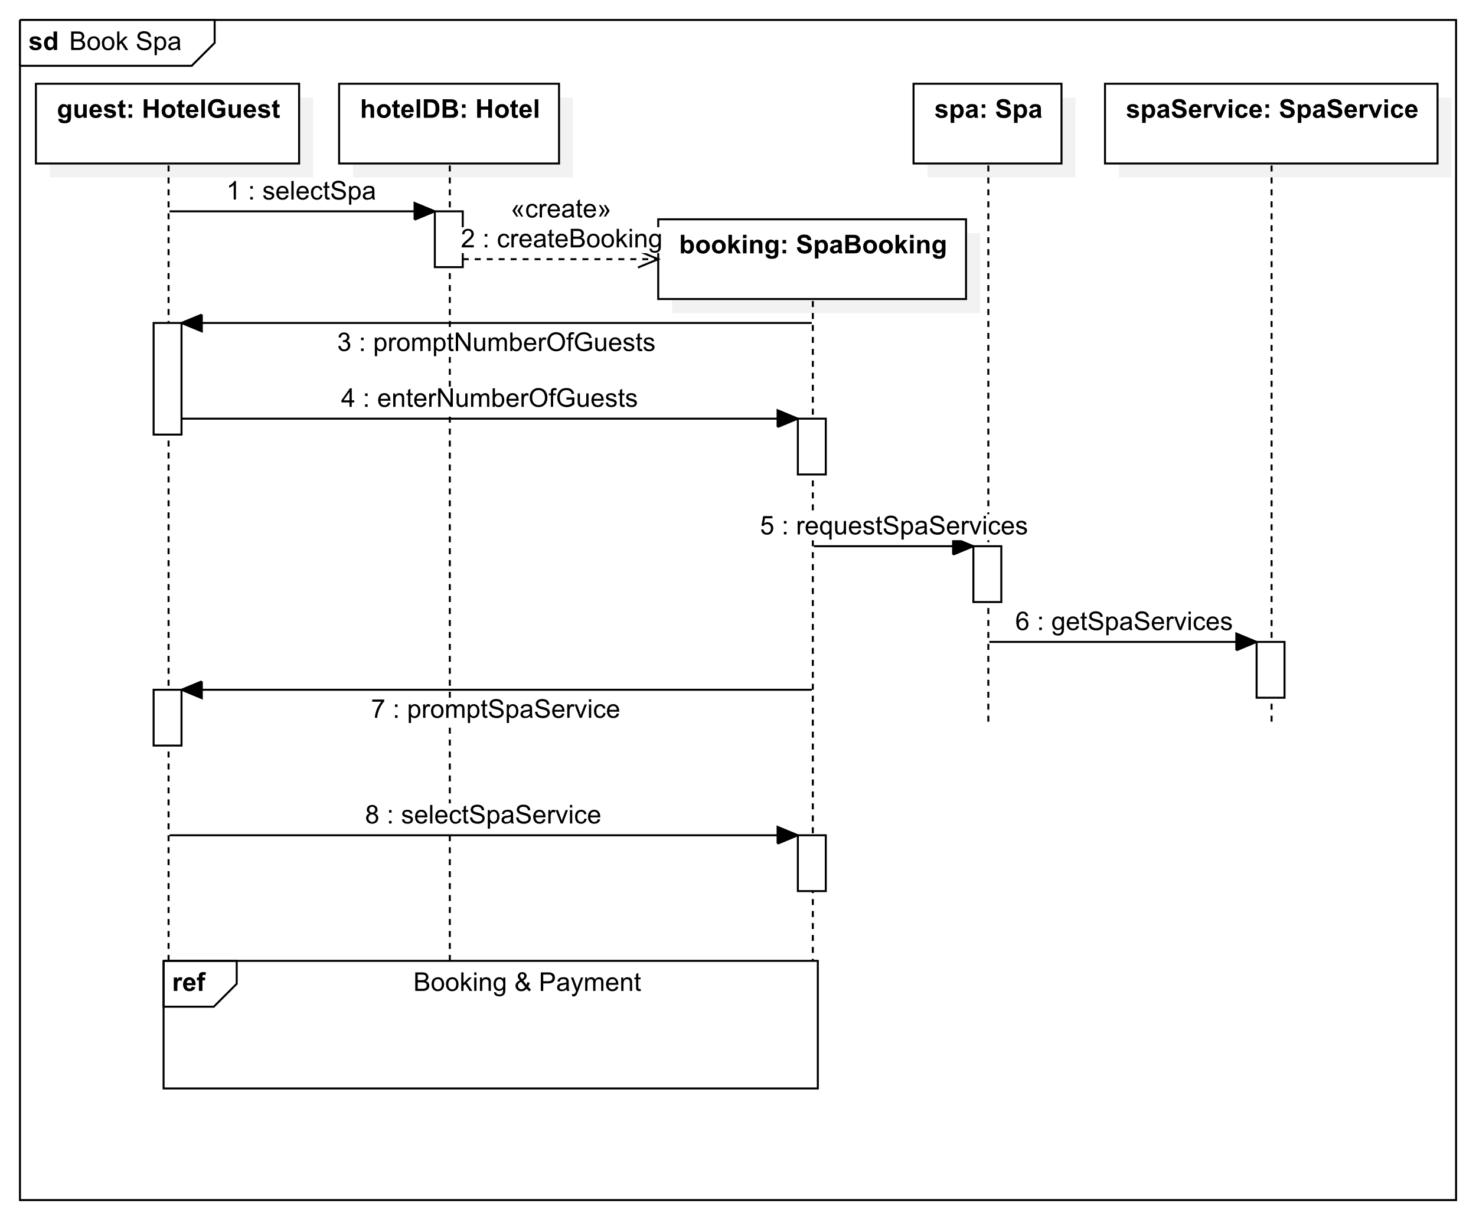

## Book Wedding

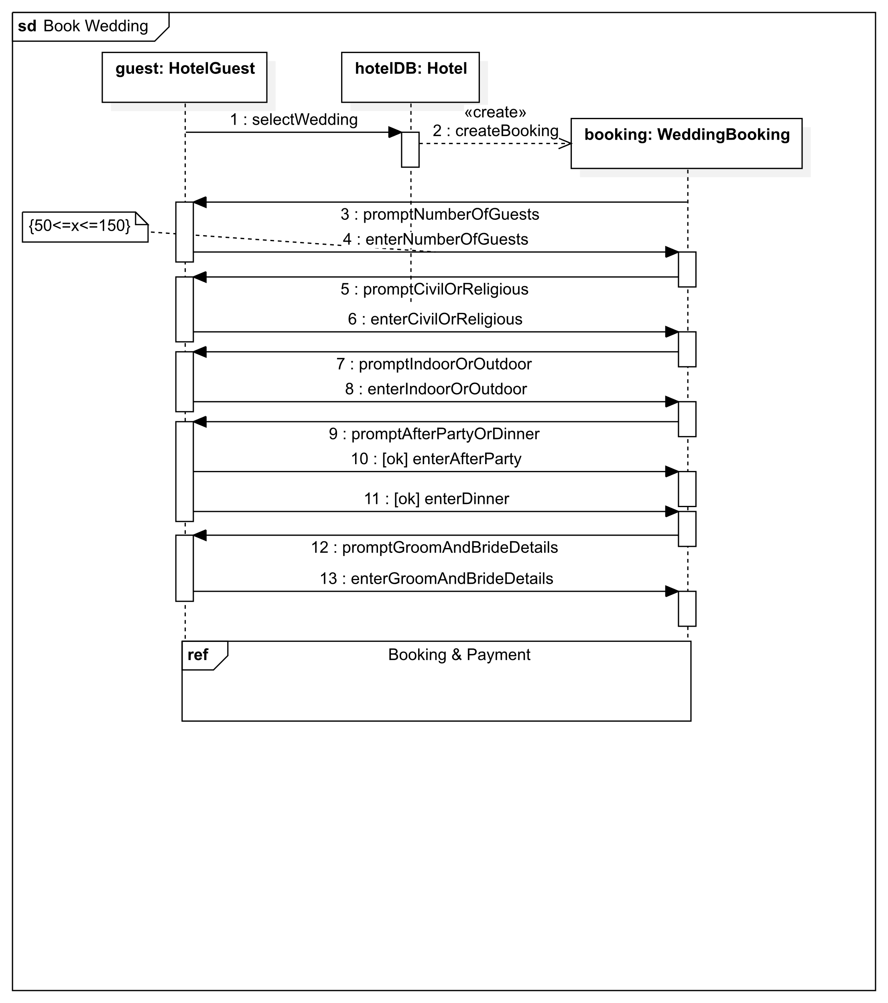

## Book Conference

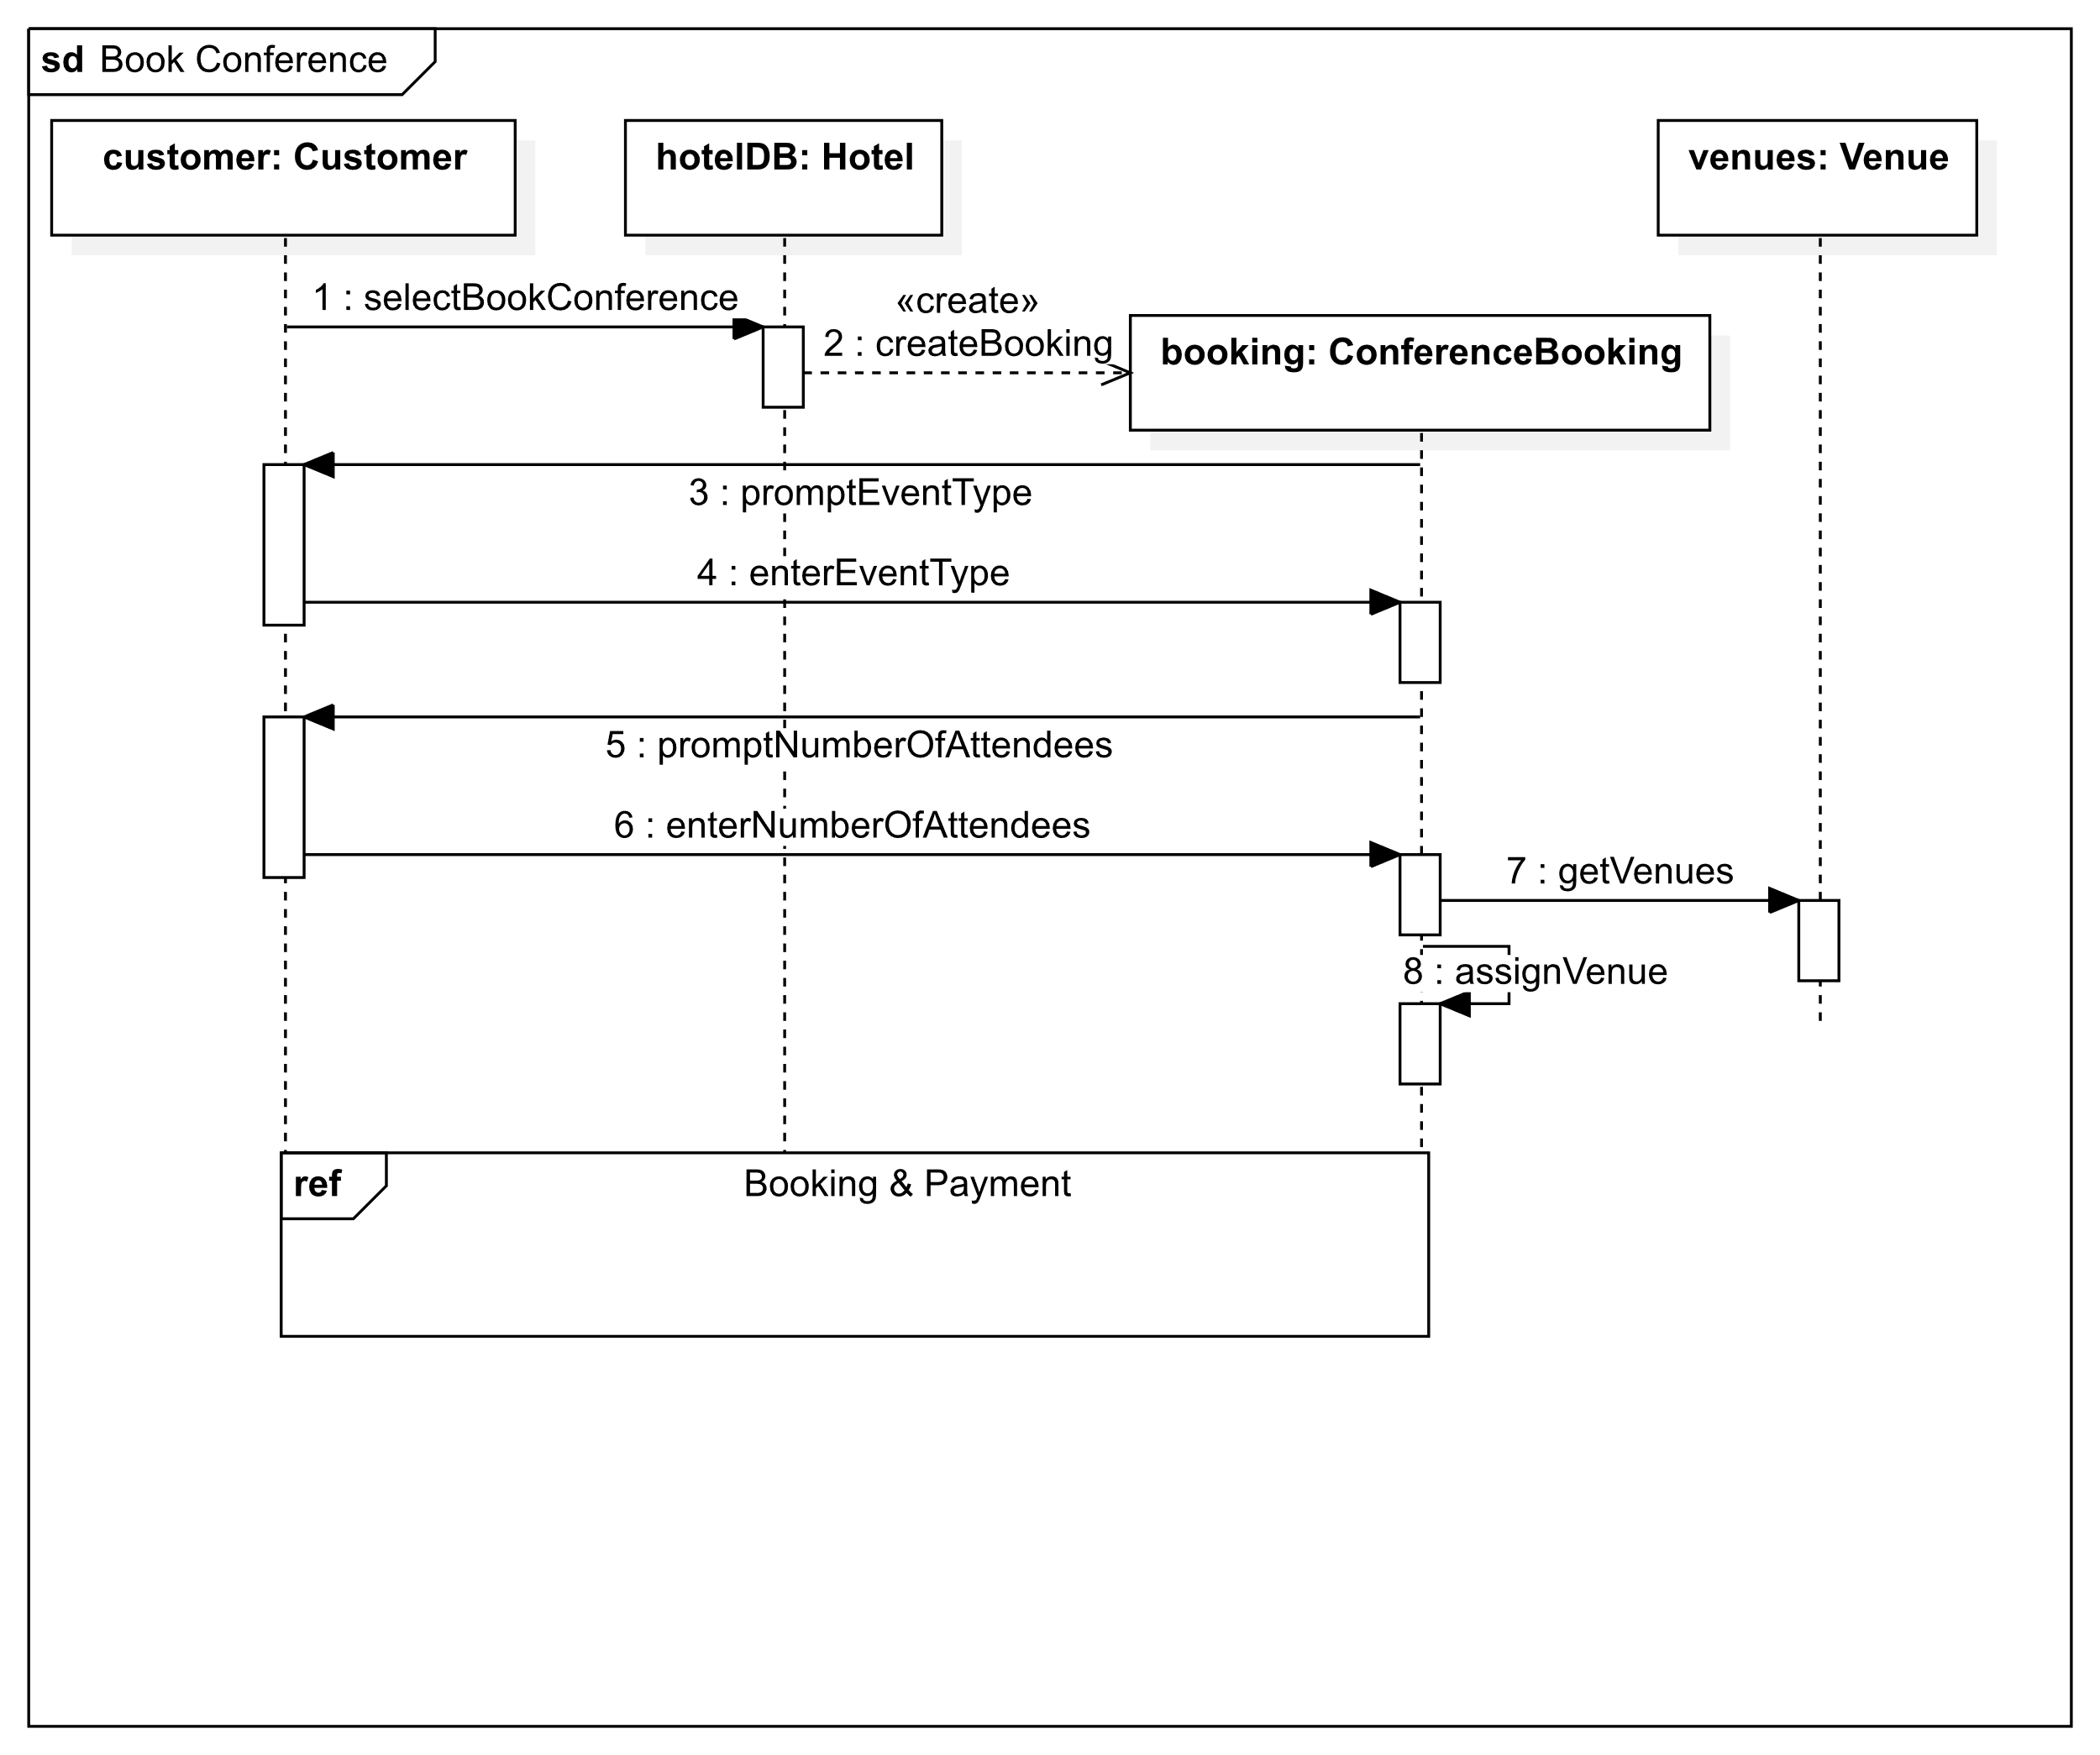

## View Availability

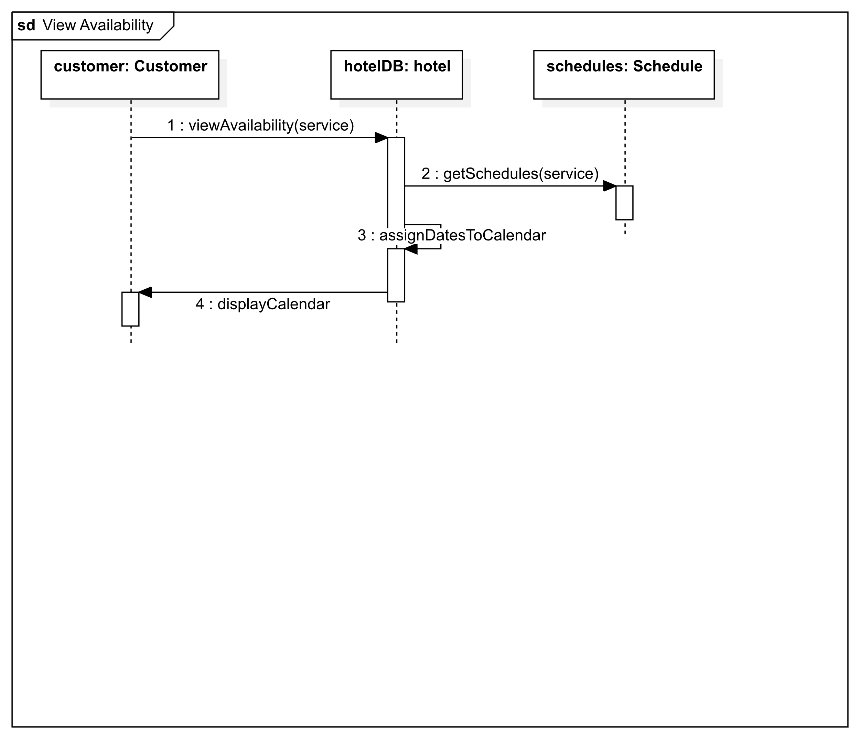

## View Menu

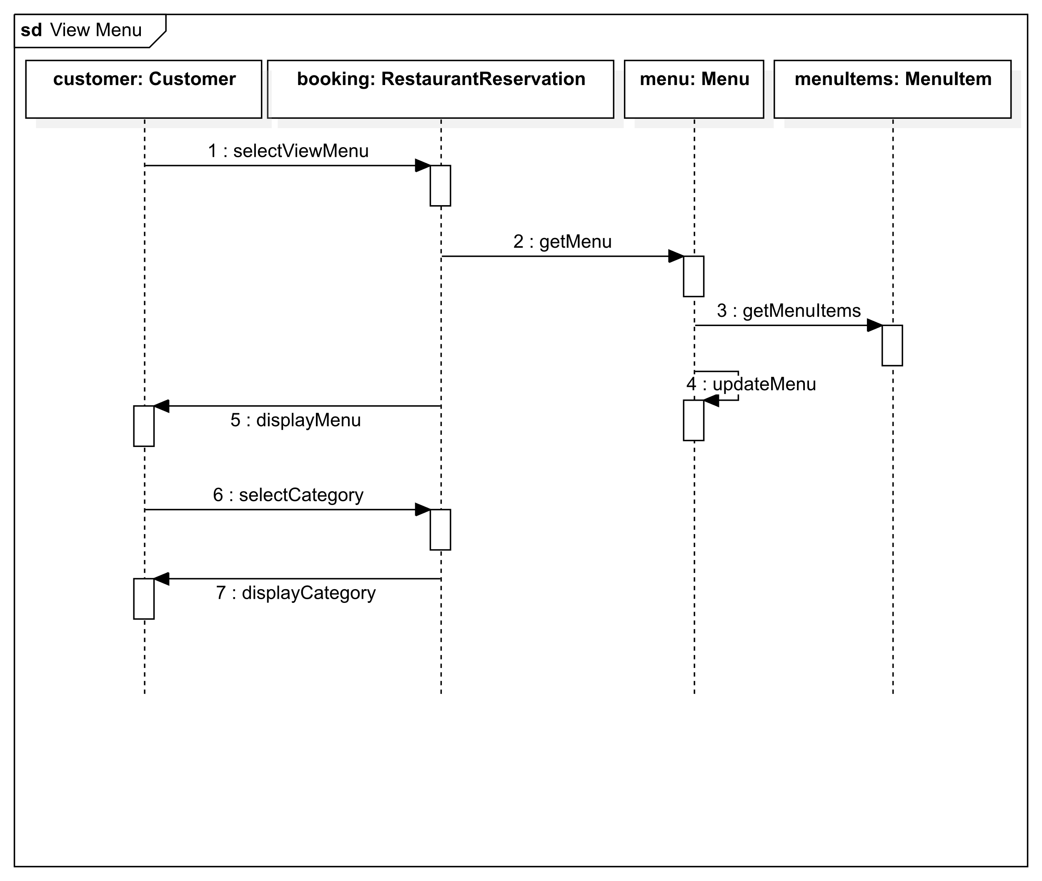

# Message Analysis Tables

## Booking & Payment

|  |  |  |  |  |  |  |
| --- | --- | --- | --- | --- | --- | --- |
| Sequence Num | Caller | Callee | Msg Name | Msg Type | Msg Param | Msg Constrain |
| 1 | customer: Customer | booking: Booking | book | Syn | - | - |
| 2 | booking: Booking | hotelDB: Hotel | availableDates | Syn | - | - |
| 3 | booking: Booking | customer: Customer | displayDates | Syn | - | - |
| 4 | customer: Customer | booking: Booking | select | Syn | date | - |
| 5 | booking: Booking | booking: Booking | updatePrice | Syn | - | - |
| 6 | booking: Booking | customer: Customer | personalDetails | Syn | - | - |
| 7 | customer: Customer | booking: Booking | provideDetails | Syn | name, phone, etc. | - |
| 8 | booking: Booking | customer: Customer | paymentDetails | Syn | - | - |
| 9 | customer: Customer | booking: Booking | providePayment | Syn | payment | - |
| 10 | booking: Booking | payment: Payment | makePayment | Syn | - | - |
| 11 | payment: Payment | booking: Booking | [ok] customerCharged | Syn | - | - |
| 12 | booking: Booking | hotelDB: Hotel | updateSchedule | Asyn | - | - |
| 13 | booking: Booking | receipt: Receipt | generateReceipt | Asyn | customerDetails, price | - |
| 14 | booking: Booking | confirmation: Confirmation | makeConfirmation | Syn | - | - |
| 15 | receipt: Receipt | customer: Customer | sendReceipt | Asyn | - | - |
| 16 | booking: Booking | customer: Customer | displayConfirmation | Syn | - | - |

## Browse Rooms

|  |  |  |  |  |  |  |
| --- | --- | --- | --- | --- | --- | --- |
| Sequence Num | Caller | Callee | Msg Name | Msg Type | Msg Param | Msg Constrain |
| 1 | guest: HotelGuest | hotelDB: Hotel | selectAccommodation | Syn | - | - |
| 2 | hotelDB: Hotel | rooms: Room | getRooms | Syn | - | - |
| 3 | hotelDB: Hotel | guest: HotelGuest | displayRoomTypes | Syn | - | - |
| 4 | guest: HotelGuest | hotelDB | selectRoomType | Syn | - | - |
| 5 | hotelDB: Hotel | guest: HotelGuest | displayRoom | Syn | - | - |
| 6 | guest: HotelGuest | hotelDB: Hotel | viewAvailability | Syn | - | - |
| 7 | hotelDB: Hotel | schedules: Schedule | getAvailability | Syn | roomType | - |
| 8 | hotelDB: Hotel | guest: HotelGuest | displayCalendar | Syn | - | - |
| 9 | Ref. Booking & Payment | | | | | |

## Book Room

|  |  |  |  |  |  |  |
| --- | --- | --- | --- | --- | --- | --- |
| Sequence Num | Caller | Callee | Msg Name | Msg Type | Msg Param | Msg Constrain |
| 1 | guest: Hotel Guest | hotelDB: Hotel | selectRoom | Syn | roomType | - |
| 2 | hotelDB: Hotel | booking: RoomBooking | createBooking | Syn | - | - |
| 3 | booking: RoomBooking | rooms: Room | getRoom | Syn | roomType | - |
| 4 | booking: RoomBooking | guest: Hotel Guest | promptNumberOfGuests | Syn | - | - |
| 5 | guest: Hotel Guest | booking: RoomBooking | enterNumberOfGuests | Syn | - | - |
| 6 | Ref. Booking & Payment | | | | | |

## Reserve Table

|  |  |  |  |  |  |  |
| --- | --- | --- | --- | --- | --- | --- |
| Sequence Num | Caller | Callee | Msg Name | Msg Type | Msg Param | Msg Constrain |
| 1 | customer: Customer | hotelDB: Hotel | selectReserveTable | Syn | - | - |
| 2 | hotelDB: Hotel | booking: RestaurantReservation | createBooking | Syn | - | - |
| 3 | booking: RestaurantReservation | customer: Customer | promptNumberOfGuests | Syn | - | - |
| 4 | customer: Customer | booking: RestaurantReservation | enterNumberOfGuests | Syn | - | - |
| 5 | booking: RestaurantReservation | restaurant: Restaurant | requestTables | Syn | - | - |
| 6 | restaurant: Restaurant | restaurant: Restaurant | getTable | Syn | - | - |
| 7 | booking: RestaurantReservation | customer: Customer | displayTables | Syn | - | - |
| 8 | customer: Customer | booking: RestaurantReservation | selectTable | Syn | - | - |
| 9 | Ref. Booking & Payment | | | | | |

## Book Gym

|  |  |  |  |  |  |  |
| --- | --- | --- | --- | --- | --- | --- |
| Sequence Num | Caller | Callee | Msg Name | Msg Type | Msg Param | Msg Constrain |
| 1 | customer: Customer | hotelDB: Hotel | selectGym | Syn | - | - |
| 2 | hotelDB: Hotel | booking: GymBooking | createBooking | Syn | - | - |
| 3 | booking: GymBooking | gym: Gym | requestGymSessions | Syn | - | - |
| 4 | gym: Gym | gym: Gym | getGymSession | Syn | - | - |
| 5 | booking: GymBooking | customer: Customer | displayGymSessions | Syn | - | - |
| 6 | customer: Customer | booking: GymBooking | selectGymSession | Syn | - | - |
| 7 | booking: GymBooking | customer: Customer | displayDuration | Syn | - | - |
| 8 | customer: Customer | booking: GymBooking | selectDuration | Syn | - | - |
| 9 | Ref. Booking & Payment | | | | | |

## Purchase Pass

|  |  |  |  |  |  |  |
| --- | --- | --- | --- | --- | --- | --- |
| Sequence Num | Caller | Callee | Msg Name | Msg Type | Msg Param | Msg Constrain |
| 1 | customer: Customer | hotelDB: Hotel | purchaseGymPass | Syn | - | - |
| 2 | hotelDB: Hotel | gymPass: GymPass | getPrice | Syn | - | - |
| 3 | hotelDB: Hotel | customer: Customer | displayPrice | Syn | - | - |
| 4 | hotelDB: Hotel | booking: Booking | createPassBooking | Syn | - | - |
| 5 | Ref. Booking & Payment | | | | | |

## Book Spa

|  |  |  |  |  |  |  |
| --- | --- | --- | --- | --- | --- | --- |
| Sequence Num | Caller | Callee | Msg Name | Msg Type | Msg Param | Msg Constrain |
| 1 | customer: Customer | hotelDB: Hotel | selectSpa | Syn | - | - |
| 2 | hotelDB: Hotel | booking: SpaBooking | createBooking | Syn | - | - |
| 3 | booking: SpaBooking | customer: Customer | promptNumberOfGuests | Syn | - | - |
| 4 | customer: Customer | booking: SpaBooking | enterNumberOfGuests | Syn | - | 1-2 |
| 5 | booking: SpaBooking | spaService: SpaService | getServices | Syn | - | - |
| 6 | booking: SpaBooking | customer: Customer | promptService | Syn | - | - |
| 7 | customer: Customer | spaBooking: Booking | chooseService | Syn | - | - |
| 8 | Ref. Booking & Payment | | | | | |

## Book Wedding

|  |  |  |  |  |  |  |
| --- | --- | --- | --- | --- | --- | --- |
| Sequence Num | Caller | Callee | Msg Name | Msg Type | Msg Param | Msg Constrain |
| 1 | guest: HotelGuest | hotelDB: Hotel | selectWedding | Syn | - | - |
| 2 | hotelDB: Hotel | booking: WeddingBooking | createBooking | Syn | - | - |
| 3 | booking: WeddingBooking | guest: HotelGuest | promptNumberOfGuests | Syn | - | - |
| 4 | guest: HotelGuest | booking: WeddingBooking | enterNumberOfGuests | Syn | - | 50-150 |
| 5 | booking: WeddingBooking | guest: HotelGuest | promptCivilOrReligious | Syn | - | - |
| 6 | guest: HotelGuest | booking: WeddingBooking | enterCivilOrReligious | Syn | - | - |
| 7 | booking: WeddingBooking | guest: HotelGuest | promptIndoorOrOutdoor | Syn | - | - |
| 8 | guest: HotelGuest | booking: WeddingBooking | enterIndoorOrOutdoor | Syn | - | - |
| 9 | booking: WeddingBooking | guest: HotelGuest | promptAfterPartyOrDInner | Syn | - | - |
| 10 | guest: HotelGuest | booking: WeddingBooking | [ok] enterAfterParty | Syn | - | - |
| 11 | guest: HotelGuest | booking: WeddingBooking | [ok] enterDinner | Syn | - | - |
| 12 | booking: WeddingBooking | guest: HotelGuest | promptGroomAndBrideDetails | Syn | - | - |
| 13 | guest: HotelGuest | booking: WeddingBooking | enterGroomAndBrideDetails | Syn | - | - |
| 14 | Ref. Booking & Payment | | | | | |

## Book Conference

|  |  |  |  |  |  |  |
| --- | --- | --- | --- | --- | --- | --- |
| Sequence Num | Caller | Callee | Msg Name | Msg Type | Msg Param | Msg Constrain |
| 1 | customer: Customer | hotelDB: Hotel | selectBookConference | Syn | - | - |
| 2 | hotelDB: Hotel | booking: ConferenceBooking | createBooking | Syn | - | - |
| 3 | hotelDB: Hotel | customer: Customer | promptEventType | Syn | - | - |
| 4 | customer: Customer | hotelDB: Hotel | enterEventType | Syn | - | - |
| 5 | hotelDB: Hotel | customer: Customer | promptNumberOfAttendees | Syn | - | - |
| 6 | customer: Customer | hotelDB: Hotel | enterNumberOfAttendees | Syn | - | - |
| 7 | hotelDB | venues: Venue | getVenues | Syn | - | - |
| 8 | booking: ConferenceBooking | booking: ConferenceBooking | assignVenue | Syn | - | - |
| 9 | Ref. Booking & Payment | | | | | |

## View Availability

|  |  |  |  |  |  |  |
| --- | --- | --- | --- | --- | --- | --- |
| Sequence Num | Caller | Callee | Msg Name | Msg Type | Msg Param | Msg Constrain |
| 1 | customer: Customer | hotelDB: hotel | viewAvailability | Syn | service | - |
| 2 | hotelDB: Hotel | schedules: Schedule | getSchedules | Syn | service | - |
| 3 | hotelDB: Hotel | hotelDB: Hotel | assignDatesToCalendar | Syn | - | - |
| 4 | hotelDB: Hotel | customer: Customer | displayCalendar | Syn | - | - |

## View Menu

|  |  |  |  |  |  |  |
| --- | --- | --- | --- | --- | --- | --- |
| Sequence Num | Caller | Callee | Msg Name | Msg Type | Msg Param | Msg Constrain |
| 1 | customer: Customer | booking: RestaurantReservation | selectViewMenu | Syn | - | - |
| 2 | booking: RestaurantReservation | menu: Menu | getMenu | Syn | - | - |
| 3 | menu: Menu | menuItems: MenuItem | getMenuItems | Syn | - | - |
| 4 | menu: Menu | menu: Menu | updateMenu | Syn | - | - |
| 5 | booking: RestaurantReservation | customer: Customer | displayMenu | Syn | - | - |
| 6 | customer: Customer | booking: RestaurantReservation | selectCategory | Syn | - | - |
| 7 | booking: RestaurantReservation | customer: Customer | displayCategory | Syn | - | - |
| 8 | Ref. Booking & Payment | | | | | |

# Test Cases

## Booking & Payment

|  |  |
| --- | --- |
| Name | TC-001 Booking & Payment |
| Requirement | The user can make and pay for a booking |
| Preconditions | 1. Available dates for the type of booking being made 2. Having a valid payment method 3. Having an email address or phone number |
| Steps | 1. Select available date(s) 2. Click book 3. Enter personal details 4. Proceed to payment 5. Choose payment method 6. Enter payment details 7. Click pay |
| Expected results | * Receiving confirmation of booking via email and/or phone * Receiving a receipt of payment via email * Database contains booking information |

## Browse Rooms

|  |  |
| --- | --- |
| Name | TC-002: Browse Rooms |
| Requirement | The user can browse rooms |
| Preconditions | 1. The user having access to the UI of the system 2. The user selecting accommodation on the UI |
| Steps | 1. Choose double room |
| Expected results | The booking contains a double room |

## Book Room

|  |  |
| --- | --- |
| Name | TC-003: Book Room |
| Requirement | The user can book a room at the hotel |
| Preconditions | 1. The user browsing rooms at the hotel 2. The user having a valid payment method 3. The user having an email address |
| Steps | 1. Enter 2 guests for a double room selected |
| Expected results | 1. The room booking contains a double room and 2 guests 2. The confirmation contains details of this booking and the dates selected |

## Reserve Table

|  |  |
| --- | --- |
| Name | TC-004: Reserve Table |
| Requirement | The user can reserve a table at the hotel’s restaurant |
| Preconditions | The user is a hotel guest or customer |
| Steps | 1. Enter 4 guests 2. Select table number T08 |
| Expected results | The reservation contains 4 guests at table number T08 |

## Book Gym

|  |  |
| --- | --- |
| Name | TC-005: Book Gym |
| Requirement | The user can book a session at the hotel’s gym |
| Preconditions | 1. The user selecting gym on the system’s UI 2. The user having a valid payment method |
| Steps | 1. Select book PT session 2. Enter 60 minutes for the duration |
| Expected results | The gym booking contains PT session and a duration of 60 minutes |

## Purchase Pass

|  |  |
| --- | --- |
| Name | TC-006: Purchase Pass |
| Requirement | The user can purchase a pass |
| Preconditions | The user is a customer of the hotel |
| Steps | Select purchase day pass for the gym |
| Expected results | The user receives a day pass sent to them via email |

## Book Spa

|  |  |
| --- | --- |
| Name | TC-007 Book Spa |
| Requirement | The user can make a booking at the spa. |
| Preconditions | 1. The user is a hotel guest or customer. |
| Steps | 1. Click book spa 2. Enter 2 guests 3. Select “royalty” treatment package 4. Continue to booking & payment |
| Expected results | 1. Booking contains “royalty” treatment package 2. Booking contains 2 guests 3. [Equivalent to TC-001 Booking & Payment] |

## Book Wedding

|  |  |
| --- | --- |
| Name | TC-008: Book Wedding |
| Requirement | The user can make a booking for their wedding. |
| Preconditions | The user is a hotel guest or customer. |
| Steps | 1. Click book wedding 2. Enter 120 guests 3. Select “religious” 4. Select “outdoor” 5. Check “after party” 6. Uncheck “dinner” 7. Enter “Darian” groom, “Vikki” bride 8. Continue to booking & payment |
| Expected results | 1. Booking contains 120 guests 2. Booking contains “religious”, “outdoor” 3. Booking contains “after party” 4. Booking contains “Darian” groom, “Vikki” bride 5. [Equivalent to TC-001 Booking & Payment] |

## Book Conference

|  |  |
| --- | --- |
| Name | TC-009: Book Conference |
| Requirement | The user can book a conference at the hotel |
| Preconditions | The user selecting book conference on the UI |
| Steps | 1. Select “Fire Training” 2. Enter 40 attendees 3. Proceed to booking and payment |
| Expected results | 1. The conference booking contains fire training as the event type 2. The conference booking contains 40 attendees |

## View Availability

|  |  |
| --- | --- |
| Name | TC-010: View Availability |
| Requirement | The user can view the availability of a desired service at the hotel |
| Preconditions | The user has selected a service type |
| Steps | 1. Select 10th-12th February on the calendar |
| Expected results | 1. The system displays if the dates 10th-12th February are available |

## View Menu

|  |  |
| --- | --- |
| Name | TC-011: View Menu |
| Requirement | The user can view the menu at the hotel’s restaurant |
| Preconditions | The user is a hotel guest or customer |
| Steps | View the desserts category |
| Expected results | The desserts category is presented to the user on the UI along with the price of each dessert option and any allergens |

# Contributions

|  |  |  |
| --- | --- | --- |
| Date | Person(s) | Work |
| 08 October 2024 | Kyle, Darian | Use case diagram initial draft |
| 09 October 2024 | Milo, Darian | User stories initial draft |
| 10 October 2024 | Kyle | Use case diagram UML |
| 14 October 2024 | Kyle | Uploaded project summary |
| 15 October 2024 | Kyle, Darian | Use case diagram final |
| 16 October 2024 | Darian, Milo, Kyle | User stories final |
| 18 October 2024 | Kyle | Scenario specifications - booking & payment, book room, browse room, book gym |
| 20 October 2024 | Darian | Scenario specification reserve table |
| 22 October 2024 | Darian | Scenario specification book wedding |
| 04 November 2024 | Darian | Scenario specification book spa |
| 04 November 2024 | Kyle | Scenario specification - view availability |
| 04 November 2024 | Milo | Scenario specification view menu, book conference |
| 07 November 2024 | Kyle | Initial class diagram |
| 07 November 2024 | Milo | Alternative class diagram |
| 09 November 2024 | Kyle | Updated class diagram and inserted it into working document |
| 13 November 2024 | Darian | Sequence diagram booking & payment |
| 14 November 2024 | Kyle | Sequence diagram browse rooms |
| 14 November 2024 | Kyle | Sequence diagram book room, reserve table |
| 15 November 2024 | Kyle | Sequence diagram book gym |
| 15 November 2024 | Kyle | Message analysis tables - browse rooms, book room, reserve table, book gym |
| 17 November 2024 | Darian | Sequence diagram purchase pass |
| 18 November 2024 | Darian | Sequence diagram book spa |
| 19 November 2024 | Darian | Sequence diagram book wedding |
| 20 November 2024 | Darian | Message analysis tables - booking & payment, purchase pass, book spa, book wedding |
| 21 November 2024 | Kyle | Sequence diagram book conference, view availability, view menu. Pasted all sequence diagrams into working document |
| 21 November 2024 | Darian | Test case booking & payment |
| 21 November 2024 | Kyle | Finished message analysis tables and pasted them into working document |
| 23 November 2024 | Darian | Test case purchase pass, book spa, book wedding; Book wedding steps rework |
| 26 November 2024 | Kyle | Test case browse rooms, book room, reserve table, book gym |
| 26 November 2024 | Kyle | Test case book conference, view availability, view menu |
| 26 November 2024 | Darian | Updated sequence diagrams book room, reserve table, book gym, book conference, |
| 26 November 2024 | Darian | Updated message analysis tables book room, reserve table, book gym, book conference, |
| 26 November 2024 | Darian | Updated message analysis tables browse rooms |
| 28 November 2024 | Darian, Milo, Kyle | Edited scenarios, sequence diagrams and message analysis tables |
| 28 November 2024 | Darian | Final editing and formatting to document and diagrams throughout |